A research report
on

“The consumer behaviour towards online shopping”

UNIVERSITY OF LUCKNOW

DEPARTMENT OF BUSINESS ADMINISTRATION



Submitted to :- Submitted by :-
Dr. Sangeeta Sahu Reetika Gupta
MBA Sem IV
INDEX

INDEX

__________________________________________________________________
Title of the Table Page No.
_________________________________________________________________
1. Declaration
2. Acknowledgement
3. Executive Summary
5. Chapter 1 – Introduction
- Definition of internet marketing
- Merits of online shopping

6. Chapter 2 – Literature Review
7. Chapter 3 – Objective of study
Objective of the study
Scope of the study
8. Chapter 4- Research Methodology
9. Chapter 5- Conclusion
10. References

DECLARATION

I, Reetika Gupta, MBA Student Of Department of Business Administration, UNIVERSITY OF LUCKNOW declare that the project entitled “The consumer behaviour towards online shopping”, is the original work done by me and the information provided in the study is authentic to the best of my knowledge.
Date of submission :
Place of submission :
Reetika Gupta

ACKNOWLEDGEMENT

The satisfaction that my successful completion of this task would be incomplete without mentioning people who made it possible whose encouragement and consistence guidance crowned my effort with success.
I would like to express my heartfelt indebtedness and deep sense of gratitude to my faculty guide Dr. Sangeeta Sahu for sharing her knowledge and giving me the proper time, guidance and generous cooperation, also to providing me an opportunity to learn outside the classroom.
I would like to thanks Head of department, Prof. J. K. Sharma sir for giving us opportunity to do this report.
Finally I thank all those who directly or indirectly helped me in my project. I express my profound thanks to my teachers as well as friend who are the constant source of encouragement for me.

Reetika Gupta

EXECUTIVE SUMMARY

Research report is an important and integral part of a good practice oriented management course. Keeping in view with the syllabus of MBA, every student has to prepare a research report. In order to fulfill this requirement , I also prepared a research report on “Consumer behaviour towards online shopping”.
Not only I used internet for this report but also I made research questions and filled by various customers.

This report consists of many research questions and customer’s perception towards online shopping and how many people likes it and how many don’t
What types of shopping website they most visit and want kind of material are mostly purchased from internet.

By preparing this report I came to know that which website is mostly visited by customer and which website product quality is good. I came to know about customers have different behaviour regarding different product. I analyzed all these things and prepared the report. I made a google form for survey and interpreted all the responses. I even consulted my friends and family for the same, interpreted all the responses and then prepared this report with a conclusion.

All the data, facts and figures mentioned in the report are correct to my knowledge and are genuine. All these figures are according to the figure going on in the current year.

The online buying is turning into additional standard day by day with the rise within the usage of internet or e-sites. Understanding customer‘s desires and needs for online shopping for, the commercialism has become difficult task for marketers

INTRODUCTION

Online searching may be a variety of electronic commerce that permits customers to directly purchase product or services from a merchandiser over the net employing an application program. Customers notice a product of interest by visiting the web site of the distributor directly or by looking out among best different vendors that displays the identical merchandise handiness and rating at totally different e-retailers. As of 2018, customers will look on-line employing a vary of various shopper and industrial merchandise.

A web look evokes the physical analogy of buying of searching for merchandise or services at a daily "bricks-and-mortar" distributor or shopping centre; the method is known as business- to-consumer (B2C) online shopping. Once a web store is ready up to alter businesses to shop for from alternative businesses, the method is known as business-to-business (B2B) on-line searching. A typical on-line store allows the client to browse the firm's vary of merchandise and services, read photos or pictures of the merchandise, on with data regarding the product specifications, options and costs. on-line stores sometimes alter shoppers to use "search" options to notice specific models, brands or things. Online customers should have access to the net and a legitimate technique of payment so as to finish a group action, like a MasterCard, AN Interact-enabled revolving credit, or a service.

Marketing is vital to know the fundamentals of market in order that they're going to understand the logic behind corporations and customers. Even once individuals share their searching experiences, they indirectly market the merchandise or services. For the foremost half, promoting deals with customers, that are vital component within the system, the purchasers decide what they wish or need. Through on-line promoting corporations aim to attract new customers by promising superior worth and maintain current ones and more develop and distribution of ideas, merchandise and services to make exchanges that satisfy individual

India has a web user‘s base of concerning 450 million as of July 2017, concerning fortieth of the population. Despite being the second-largest user base in world, solely behind China (650 million, forty eight of population), the penetration of e-commerce is low compared to markets just like the u. s. (266 million, 84%), or France (54 M, 81%), however is growing at Associate in Nursing unexampled rate, adding around half-dozen million new entrants each month. The business accord is that growth is at Associate in nursing inflection purpose. In India, money on delivery is that the most well-liked payment technique, accumulating seventy five of the e- retail activities. Demand for international shopper product (including long-tail items) is growing abundant quicker than in-country offer from licensed distributors and e-commerce offerings.

According to study done by Indian Institute of e-Commerce, by 2021 Bharat is predicted to get
$100 billion on-line retail revenue out of that $35 billion are going to be through fashion e- commerce. On-line attire sales are set to grow fourfold in coming back years.
As of 2018, the largest e-commerce companies in India are

Amazon: World leader e-commerce company Amzon has emerged because the upmost e- commerce i.e. e-commerce in India moreover, in previous couple of years. With a
large vary of merchandise Amazon has additionally started specializing in their delivery service by providing delivery at intervals at some point to their customers. To counter its competitors, quite 8500 crores are endowed by Amazon world in Amazon Asian nation.

Flipkart: supported in 2007 by Sachin Bansal and Binny Bansal, Flipkart is one amongst the best e-commerce corporations in Asian nation. It’s set an ideal example for all commence aspirants by growing one thousand times over a decade.
Flipkart provides all reasonably merchandise, from merchandise of basic-needs
to fashionable and opulent products that are possible. The value of Flipkart is North American nation $15 billion presently.

Walmart: one amongst the largest retail companies within the world, has bought a
serious share of Flipkart, the Indian e-commerce big. The deal is an officer one and Walmart is paying regarding $16 billion for the seventy seven share that it's shopping for. The remaining share is maintained by a number of the recent stakeholders together with Binny Bansal, co-founder of Flipkart.

Snapdeal: Started in 2010 by 2 graduates Kunal Bahl and Rohit Bansal, Snapdeal ranks third within the prime 10 lists of e-commerce corporations. Headquartered in Indian capital,
Snapdeal provides a large selection in its merchandise together with enticing daily native deals
such as on restaurants, spas, movement apps etc.

Paytm: As the form suggests ‗payment through mobile, it permits you
to create payments on-line through its e-wallet. This urban centre based mostly e- commerce complete was commenced in 2010 however it witnessed boom within the year 2016. thanks to conclusion
and government‘s support for Digital Asian nation, in last 2 years it's achieved quite three hundredth year-on-year growth.

Jabong: Launched within the year 2012, this e-commerce major primarily deals in
fashion products. It provides a variety of around three hundred brands for teenagers, men and girls by keeping in mind regarding today‘s trend.

EBay: primarily associate degree Yankee MNC, eBay is additionally one of the distinguished e-commerce corporations within the world. It’s diversity
of merchandise and one amongst the add-on options is that it permits you to to sell or purchase you’re used or second-hand product on acquiescent rates.

Shopclues: Rendering exciting and jaw-dropping deals each day, this e-commerce company was commenced by Sandeep and Radhika Agarwal. Delivering merchandise to over
3000 pin codes, Shopclues has associated quite five hundred thousand sellers with itself.

MakeMyTrip: Headquartered in Gurgaon, MakeMytrip is essentially a movement web site that sells bus, train, and air tickets, vacation packages on with nice deals and exciting offers.

Homeshop18: Having launched India‘s 1st 24-hour Home looking TV channel, this e- commerce major provides you a large style of home appliances together with gazettes like cameras, mobiles, laptops and far a lot of.

Bookmyshow: the primary web site that involves our
mind whereas booking flick tickets online is BookmyShow. Headquartered in metropolis, Bookmyshow is that the leading portal in booking tickets for amusement functions like movies, plays, sports events etc.

Zomato: this can be a platform that permits you to order food online; the partner eating house can deliver the ordered food at your step. Zomato is
growing speedily since it's additionally launched gold membership in Asian nation meaning it has busy with premier restaurants of urban centre, metropolis and metropolis.

Digital India is a campaign launched by the Government of India to promise the government services are created obtainable to voters electronically by improved on-line infrastructure and by increasing net property or by creating the country digitally sceptres within the field of technology. The initiative includes plans to attach rural areas with high-speed net networks. Digital Asian nation consists of 3 core elements,

- Development of secure and stable digital infrastructure,
- Delivering government services digitally, and
- Universal digital acquisition.

Highlighting the on top of paragraph, digital Asian nation helps even the agricultural individuals are today the patron of on-line searching with the assistance of a sensible stable digital infrastructure.Every side of on-line searching is digital, which means that's electronic info that is offline advertising and sales tool.

1.1 Definition of Internet marketing :

Internet promoting, or on-line promoting, refers to advertising and promoting efforts that use the online and email to drive direct sales via electronic commerce, additionally to sales leads from websites or emails. Digital marketing could be a kind of marketing that connects shoppers with sellers electronically victimization interactive technologies like emails, websites, on-line forums and newsgroups, interactive tv, mobile communications etcetera (Kotler and Armstrong, 2009). It facilitates many-to-many communications thanks to its high level of property and is sometimes dead to market product or services in a very timely, relevant, personal and cost-efficient manner (Bains et al., 2011).
Internet is employed as a channel as part of marketing. It’s had a large impact on promoting since it absolutely was fictional and realised to be a good marketing tool. it's helped the businesses to be able to target their potential customers a lot of in person and knowing more concerning them has helped in knowing however to approach completely different customers to urge to their wants. Today the thought of net promoting has extended and opened a lot of opportunities to corporations in their marketing.
The basics of promoting combine are still applicable and net offers new opportunities to adapt them.

Product:
The internet leads to quicker discovery of client wants, bigger customization of the product to the client wants, quicker product testing, and shorter product life cycles. Providing complete and relevant product info is crucial so as for the shoppers to urge a practical image of the merchandise and to create the product offered a lot of engaging.

Price:
Price is that the most versatile part since it is tailored quickly to the market‘s demand. The price on the net has become terribly competitive. There are 2 reasons for that:
one is value transparency on the net because it is abundant faster and easier to compare costs by visiting company‘s websites or by victimization price comparison sites. The different reason is that the ability to cut back prices like store house and worker costs. The net payment that uses principally debit cards is seen as associate degree economical, convenient and versatile payment methodology for each corporations and customers.

Place:
The place part of the promoting combine historically refers to wherever the product is distributed to customers. Allen and Fjermestad argue that the net has the best implications for place in the promoting combine as a result of it has a massive market place.
Corporations will gain advantage of the low price of advertising internationally while not the need of a supporting sales infrastructure in numerous countries.

Promotion:
The promotion part of the promoting combine refers to however marketing communications are used to inform customers concerning associate degree organization and its product. By victimization promotional tools on the net such as on-line offers, oft updated info and direct e-mail reminders, corporations will encourage customers to go to their sites.

Internet promoting Tree:

The far-famed promoting strategy followed by the organization are such that search engine marketing, Directories &amp; Listing, Email promoting, social media promoting, packaging and on-line advertising. In the recent years several surveys has over that Social media promoting plays an important role within the market space.

1.2 Merits of on-line shopping:

Due to speedy growth of technology in the recent years, business organizations have move from the standard methodology of mercantilism the product to electronic method mercantilism product that paves the expansion of the many on-line stores. Business organizations use net as a main vehicle to conduct industrial transactions within the on-line platform.

The online searching deserves are listed below

- Saves time and efforts,
- Convenience of searching at home,
- Wide selection / vary of product are on the market, sensible discounts / lower costs,
- Get careful info of the merchandise, we have a tendency to will compare numerous models / brands,
- No pressure searching, Online searching saves time, Comparisons,
- Availability of on-line look,
- Online searching saves cash Problems two-faced by on-line consumers:
Although online shoppers get pleasure from several edges they're additionally prey for the net fraud in sure circumstances. The most disadvantage of on-line searching is physical verification
regarding the quality of the merchandise is not on the market and cannot receive the product at once. Consumers had to attend till the merchandise reaches. Generally it's higher to possess associate degree item instantly than keep expecting it for several days.

A recent study done by Bright Local states that eighty eight of U.S. shoppers scan on-line reviews "to verify whether or not an area business could be a sensible business"

At least occasionally—39% do therefore often. Also, seventy two say positive reviews lead them to trust a business a lot of, whereas eighty eight say that in "the right circumstances", they trust on-line reviews the maximum amount as personal recommendations. Whereas scammers are progressively taking advantage of the ability of social media to conduct criminal activity, smart risk managers and their insurance corporations also are finding ways in which to leverage social media info as a tool to combat insurance fraud. For instance, associate degree dislocated employee was out of labour on a worker's compensation claim however couldn't resist enjoying an athletics on an area semi-professional sports team.
Through social media and net searches, investigators

CHAPTER-2 LITERATURE REVIEW
In this Research study the attempt has been made by the researcher to identify the previous literature pertaining to the topic to draw a deeper insight into the concept. The study of previous related literature pertaining to consumer‘s attitude towards online shopping behaviour would immense help the researcher in understanding the contributions made by others and in creating a link to the chosen topic by the researcher.
This has helped the researcher to identify the contributions and the research gap which facilitated in designing the framework of the study and in the formulation of the questionnaire for data collection and conducting the research.

Dr.V Vijayalakshmi & Dr.R.Lakshmi (2018) Mostly youngsters and youth generation (19-30 age group) are very much interested in online buying because they know about technology and e- shopping.

As per an ASSOCHAM-Resurgent joint study,(2018) online shopping is expected to clock annualised growth of 115 percent this year, aided by fast-increasing data consumption and improvement in logistics, along with a number of offers presented by e-commerce platforms.

Na Li & Ping Zhang (2002) found that men are more adopting in online shopping, Female shoppers are found to prefer using catalogues to shop at home. It is found once female showed preference in online shopping, they will shop more frequently online than their male counterparts.

Dr. Vijendra Pratap Singh (2018) consumer behaviour towards online shopping tells how competitive advantage is eluding day by day business has been mark with high degree of dynamics. In the monopolistic competitive market every company is having almost the same technology easily. This has resulted in the concept of luring the maximum customer by becoming more and more innovative. How much receptive company can become to their needs and aspirations. All these have force the companies to register their presence and take the help of latest technology to endeavour, The one technology is online shopping. This paper is being written keeping in view of attitude of common people of India towards online shopping.

Professor Pritam P. Kothari , Professor Shivganaga tells that the growing number of internet users in India provides a bright prospects for online shopping. If E- marketer s know the key factor affecting behaviour of consumer and its relationship then they can formulate their marketing strategies to convert the potential customer into the loyal ones and retaining existing online consumer. This research paper highlight on factors which online customer keep in mind while purchasing a product online. Internet has changed the way consumer purchases the product online.

Dr.Anuprit kaur Internet is the rapidest growing media during the past decade. This study aims to establish a preliminary assessment, evaluation and understanding of the characteristics of online shopping. An effort has been made to investigate online consumer

behaviour, which in turn provides E-marketers with a constructional framework for fine- tuning their E-businesses’ strategies.

Jarvenpaa journal of Electronic Commerce Research, VOL.6, NO.2, (2015) it is an early stage in internet development in terms of building an appropriate dedicated model of consumer buying behaviour.

(Ahmed, 2012) Concerns of price, quality, durability and other product-related aspects are the main drivers of buying decision in developed countries but the considerations could be vary from the developing countries

(Sylke et al., 2004) The growth rate of electronic commerce in India, however, has yet been much below anticipation; its proportion of total retail business is still small due to its certain limitations.

(Garbarino & Strahilevitz, 2004; Korgaonkar & Wolin, 1999; Van Slyke et al., 2002) previous researches suggested that men are more likely to purchase products and/or services from the Internet than women.

Mohammad Anisur Rehman The World Wide Web has propelled in no small extent of changes in the attitude and behavior of people all over the world. Due to this blessing, online shopping has emerged which influenced the lives of ordinary citizens. The survey reveals that consumers shop online to save time, and for available varieties of products and services. Both male and female both have the same type of behavior towards liking and disliking factors; they like home delivery facility and dislike inability to touch and feel the product most. They acquire online shopping information from websites especially from the social network and purchase apparels, accessories mostly through cash on delivery method of payment. The most of the consumers are concern about the security of the payment system, and their overall online shopping satisfaction is mixed.

CHAPTER -3 OBJECTIVE OF STUDY
3.1 Objectives of the study:

- To study the relationship between consumer attitude and online shopping behaviour
- To determine the relationship between the demographic variables and factors of consumer attitude
- To find the factor influencing consumers approach towards online shopping

  - Scope of the study:

- To determine which feature impacts the consumer to go for online shopping
- To determine which feature of the websites attracts the user to purchase the product from online shopping website
- To know whether online shopping is useful for the user
- To analyse which factors encourage the user to buy online

CHAPTER-4 RESEARCH METHODOLOGY
4.1 Research Methodology:
Both Primary data and Secondary data are used in this research study Research Instrument:
The structure build questionnaire is used as the research instrument for the study.

Convenience sampling method:
The researcher used convenience sampling method for data collection. The samples were collected among various areas in and around Delhi.

Statistical tools used are:
SPSS
Excel
Microsoft Word

4.2 Limitations of the study:
- The sample size is limited to 80
- The analysis is conducted only in selected areas of Delhi Ncr city
- The study basically is based on the perception of the respondents
- The data was collected through structured questionnaire and examined based on the information given by the respondents

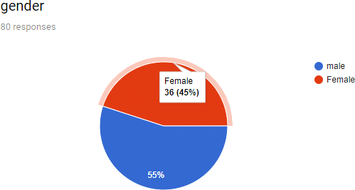

The pie chart depicts that 45% of the total respondents are female who prefer online shopping 55% of the total respondents are male who prefer online shopping and there behaviour will determine.

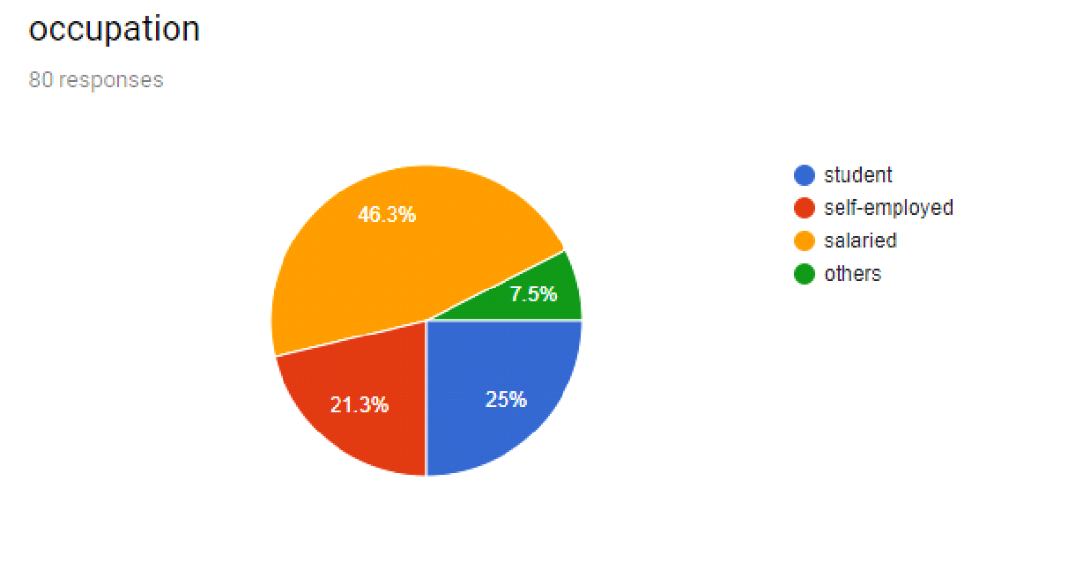Internation

On the basis of occupation 25% are the student who prefer online shopping.21.3% are the respondents are self-employed 46.3% are salaried people & 7.5% are others who prefer online shopping
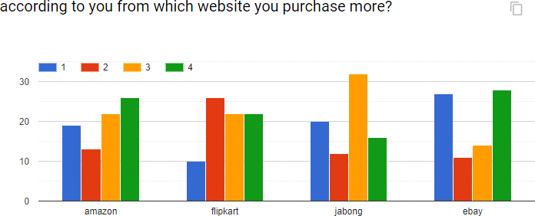

This histogram depicts that most of t he people prefer online shopping from Jabong after that amazon site is being preferred then flipkart and then ebay for the online shopping purpose.

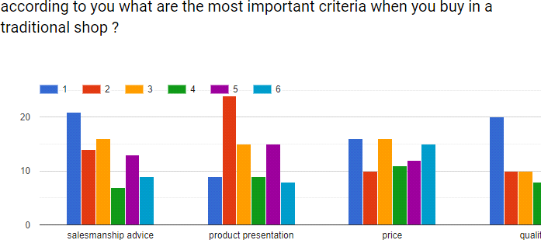

According to this histogram product presentation matters a lot when we buy in a traditional shopping . salesmanship advice also matters in traditional shopping as this hsitogram depocts after that price matters an dlast quality depends on online shopping criteria in traditional shopping.

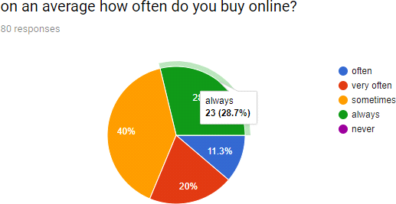

This pie chart depicts 28.7% of the respondents always prefer online shopping.11.3% of the respondents prefer often online shopping.20% of the respondent prefer very often &40% respondents prefer sometimes buying online.

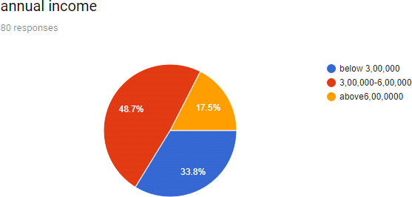

This pie chart depicts 33.8%of the respondents annual income is below 3,00,000 & 48.7% are respondents annual income is between 3,00,000-6,00,000 &17.5% of the respondent annual income is above 6,00,000.

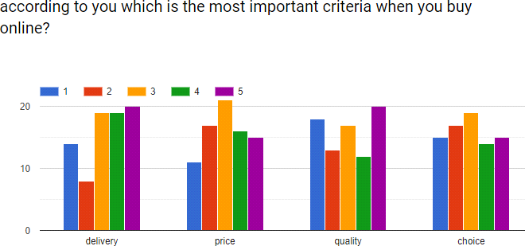

This histogram depicts that the most important criteria when people buy online is the price which matters a lot and then quality matters which quality particular is providing after that

delivery option and the last is depends upon the choice of the person who buys online and for him what matters a lot.

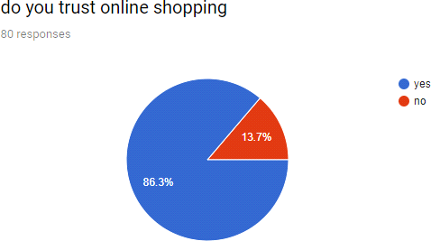

This pie chart depicts 86.3% respondents believes in online shopping and else 13.7% don’t trust online shopping.

CHAPTER 5 – CONCLUSION

In this analysis, an attempt has been created by the research worker to establish the consumer‘s perspective towards online buying behaviour

The online buying is turning into additional standard day by day with the rise within the usage of internet or e-sites. Understanding customer‘s desires and needs for online shopping for, the commercialism has become difficult task for marketers. Specially understanding the consumer‘s attitudes towards online shopping, creating improvement within the factors that influence shoppers to buy online and operating on factors that have an effect on consumers to shop online can facilitate marketers to realize the competitive advantage over the others. Thus our study has targeted primarily on these analysis queries.

- The classification of web shoppers in terms of human ecology.
- The factors that influence shoppers to buy online and to determine what factors are most interesting for web shoppers.

We foresee that our findings will provides a clear and wide image to on-line retailers and can facilitate them perceive the precise factors that influence shoppers to buy online, so that they will build up their methods to cater the necessity of web shoppers.

This has helped the research worker to spot the contributions and also the analysis gap that facilitated in planning the framework of the study and in the formulation of the form for knowledge assortment and conducting the analysis.

REFERENCES

- www.domain-b.com, www.prdomain.com, and www.prdomain.com.
- www.yahoo.com
- www.altavista.com
- www.surveys.com
- http://www.business.com/directory/advertising_and _marketing/market_ research/consumer_behaviour
- Marketresearch.com
- Wikipedia.org

